**Prerequisites:**

1. **Check System Requirements:**
   * Verify that your computer meets the minimum system requirements for Windows 11. This includes CPU, RAM, storage, and other specifications.
2. **Backup Your Data:**
   * Before any major operating system installation, it's essential to back up your important data to prevent data loss.

**Installation Steps:**

1. **Download Windows 11:**
   * Visit the official Microsoft website to download the Windows 11 installation tool or ISO file.
2. **Create Installation Media:**
   * If you downloaded an ISO file, you can create a bootable USB drive using tools like Rufus or the official Windows USB/DVD Download Tool.

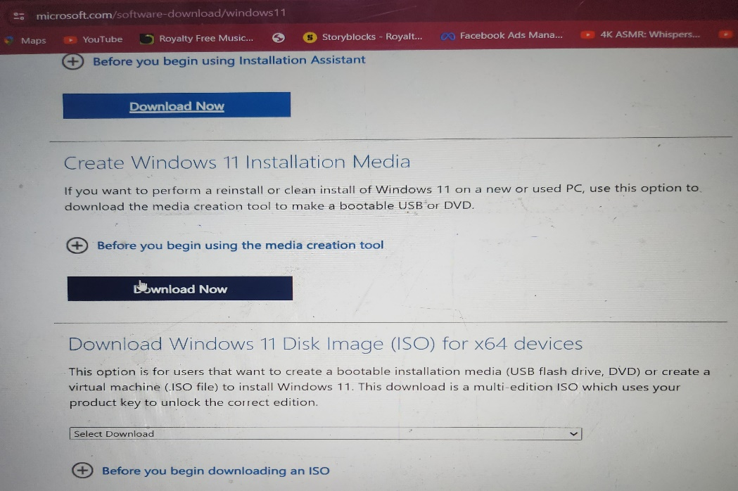

1. **Boot from Installation Media:**
   * Insert the USB drive into your computer.
   * Restart your computer and enter the BIOS or UEFI settings to set the USB drive as the primary boot device.
   * Save the changes and exit the BIOS/UEFI settings.
2. **Install Windows 11:**
   * The Windows 11 installation process will start.
   * Follow the on-screen instructions, selecting language, time, and keyboard input preferences.

* + When prompted, choose the installation type (usually "Custom" for a clean installation).

1. **Partition and Format:**
   * If you are performing a clean install, you may need to partition and format your drive.
   * Select the drive where you want to install Windows 11 and follow the prompts to create a new partition.

1. **Product Key and Activation:**
   * Enter your Windows 11 product key when prompted.
   * Follow the instructions to activate your copy of Windows 11.
2. **Set Up Windows 11:**
   * Complete the setup process by creating or signing in with a Microsoft account.
   * Customize your settings, including privacy preferences.
3. **Windows Update:**
   * After installation, check for Windows updates to ensure you have the latest security patches and drivers.
4. **Install Drivers and Software:**
   * Download and install the necessary drivers for your hardware.
   * Install your essential software and applications.
5. **Enjoy Windows 11:**
   * Once the installation is complete, you can start using Windows 11 on your computer.

Remember that the steps might vary slightly based on your specific hardware and the version of Windows 11 available at the time of installation. Always refer to the official Microsoft documentation for the most accurate and up-to-date instructions.